**Assignment Deploy Any PHP application on Kubernetes cluster**

**Updated Directory Structure**

**todo-app/**

│

├── index.php

├── simple_todo.sql

├── Dockerfile

├── docker-compose.yml

├── k8s

├── mysql

├── php-app

├── phpmyadmin

**This all files I have uploaded on my github profile you can check this on this url**

https://github.com/Abhijeet41/3tier_todo_app  
  
  
**Step 1: modify some changes in index.php**

Replaced this line

$connection = mysqli_connect('localhost','root','','simple_todo');   
 with

$connection = mysqli_connect('db','root','rootpassword','simple_todo');

**Step 2: Install Docker in Ubuntu Ec2 Instance**

Already installed docker using below reference link <https://www.digitalocean.com/community/tutorials/how-to-install-and-use-docker-on-ubuntu-22-04>

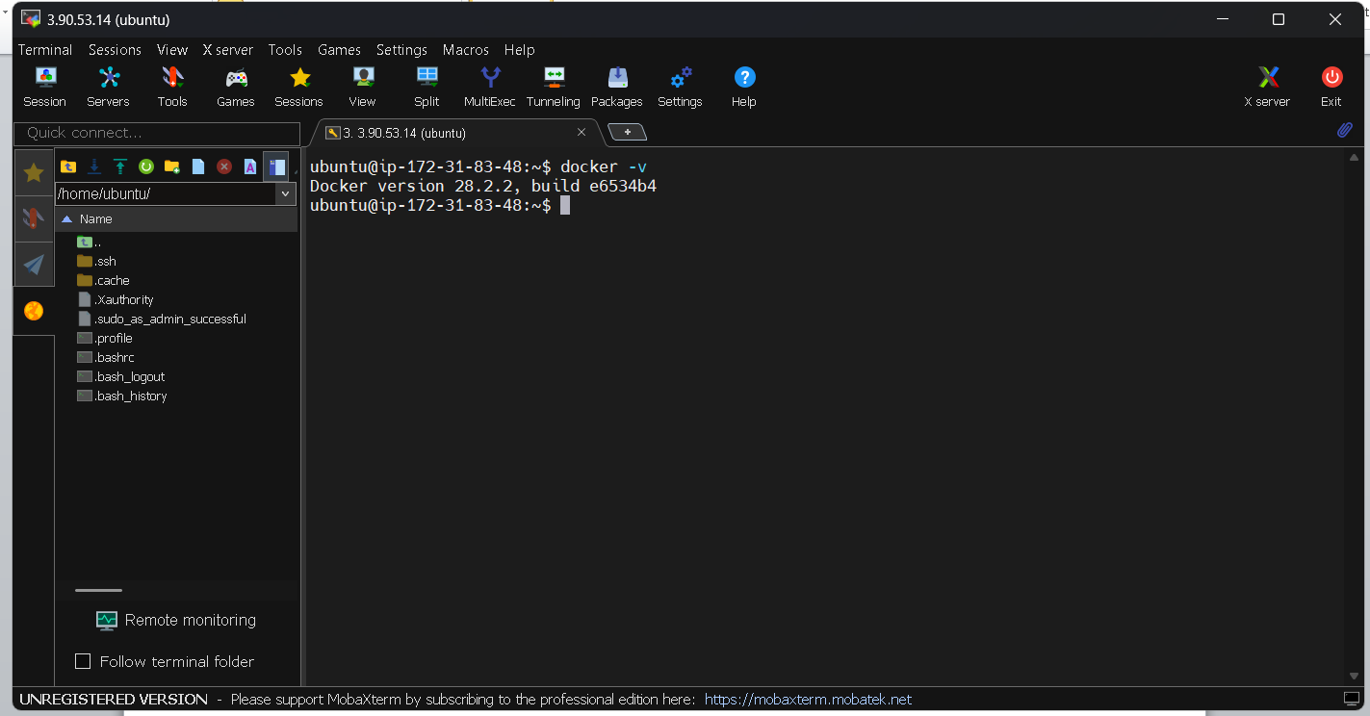

**Step 2.1 :- Dockerfile** for PHP-Apache

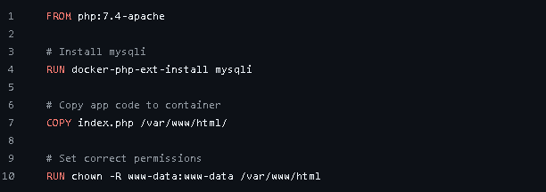

**Step 2.2 :- docker-compose.yml** File

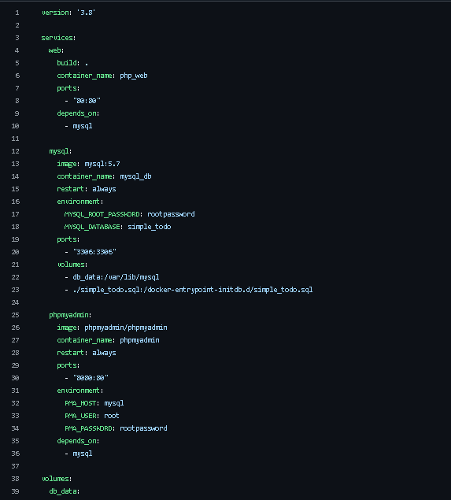

**Step 2.3 :- Build and Run**

docker-compose build

docker-compose up -d

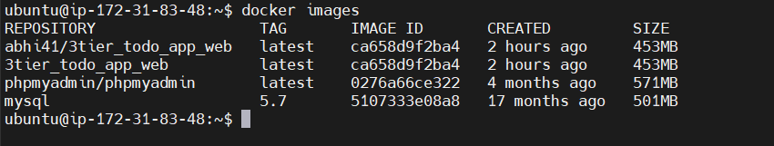

**Step 2.4 :- Upload php-app docker image on docker hub later we used for k8s**

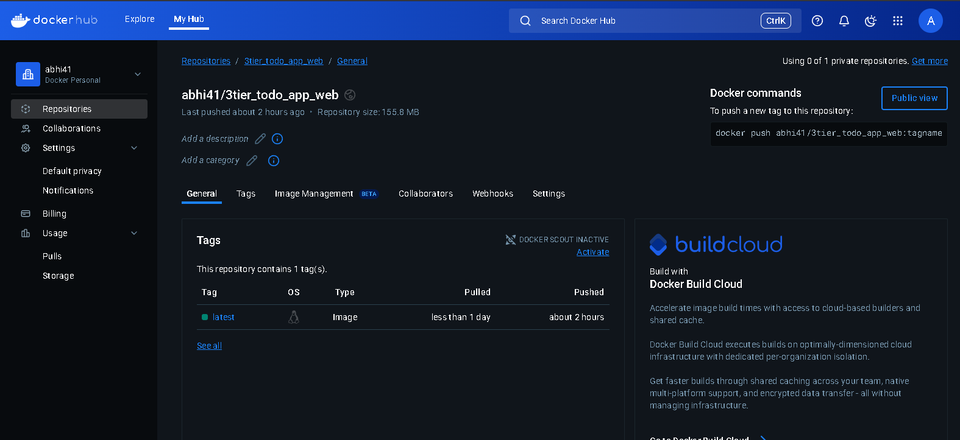

**Step 3: Configure Kubernetes cluster setup in aws**

I have already configure my k8s using kops

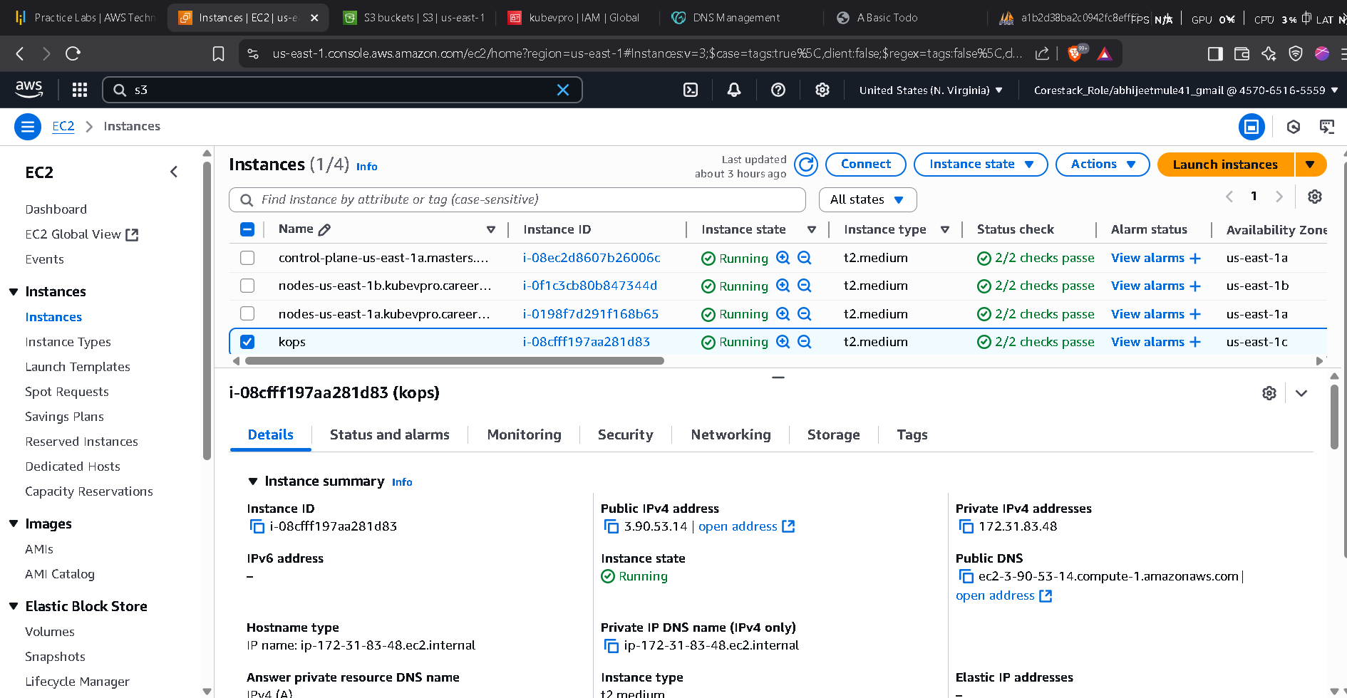

**Now new updated Project Structure for k8s**

k8s/

├── mysql/

│ ├── deployment.yaml

│ └── service.yaml

├── php-app/

│ ├── deployment.yaml

│ └── service.yaml

├── phpmyadmin/

│ ├── deployment.yaml

│ └── service.yaml

**Now Step By Step Deployment Starting with MySql first**

**2. MySQL**

mysql/deployment.yaml

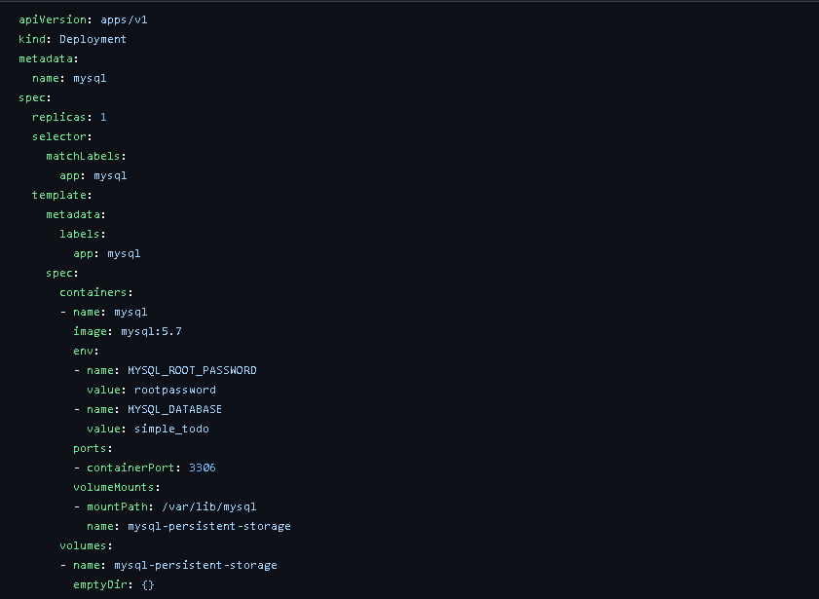

k8s/mysql/service.yaml

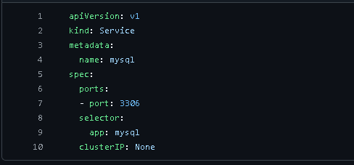

**2. php-app**

k8s/php-app/deployment.yaml

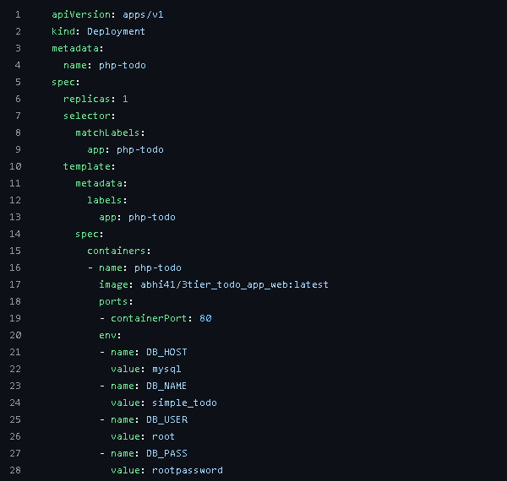

k8s/php-app/service.yml

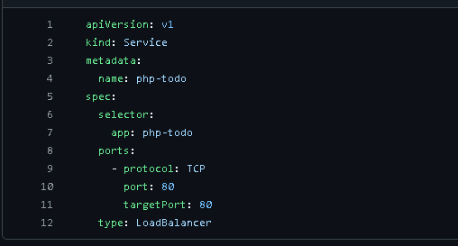

**3. phpmyadmin**

k8s/phpmyadmin/deployment.yaml

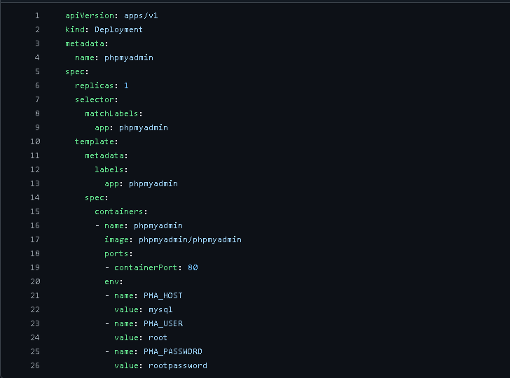

k8s/phpmyadmin/service.yaml

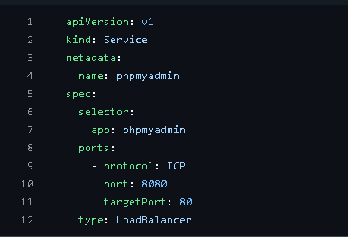

**Now Create or Apply All Deployment and Service file using below commands**

**kubectl apply -f k8s/mysql/**

**kubectl apply -f k8s/php-app/**

**kubectl apply -f k8s/phpmyadmin/**

**kubectl get svc**

O/P

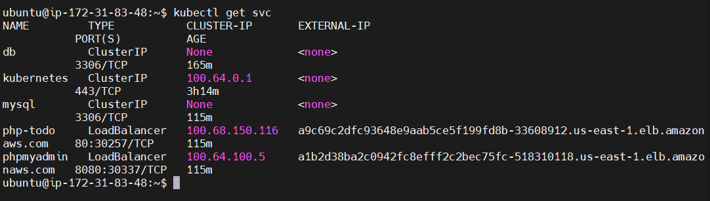

**This for my php app**

**http://a9c69c2dfc93648e9aab5ce5f199fd8b-33608912.us-east-1.elb.amazonaws.com/index.php**

**This for my php admin**

**http://a1b2d38ba2c0942fc8efff2c2bec75fc-518310118.us-east-1.elb.amazonaws.com:8080/index.php**

**Now Final Output on Web Browser**

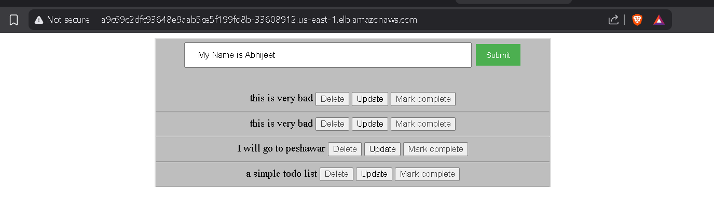

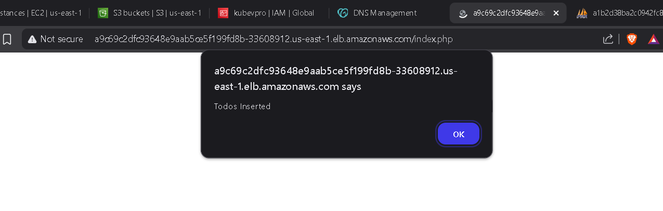

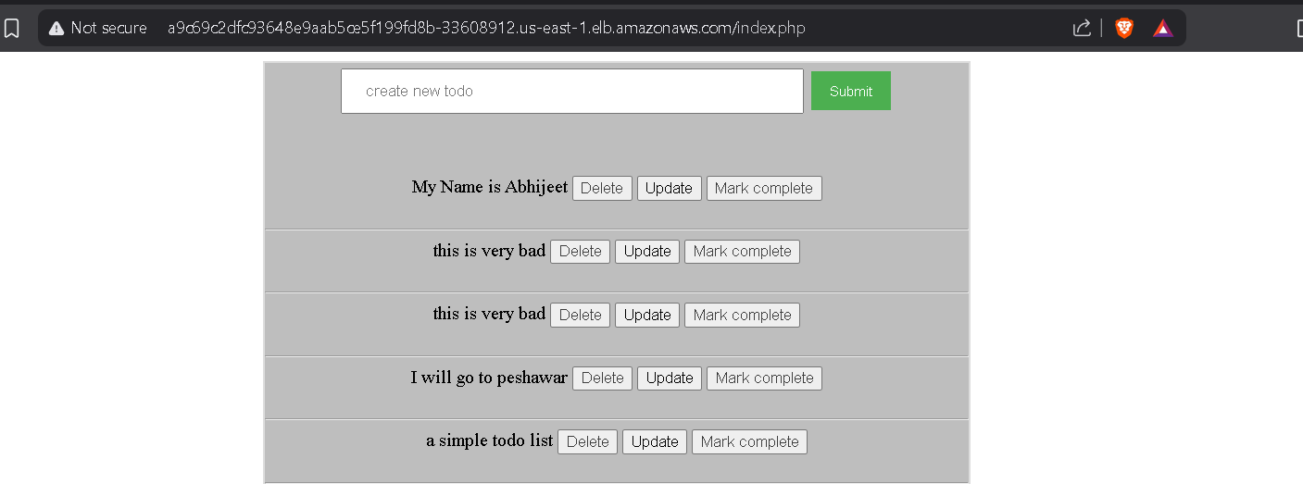

We can checked our value inserted in Database

